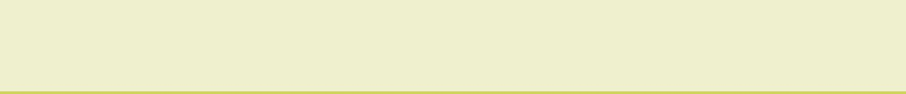
ACTIVE LEARNING TEMPLATE: Growth and Development

STUDENT NAME

DEVELOPMENTAL STAGE school Age REVIEW MODULE CHAPTER

EXPECTED GROWTH AND DEVELOPMENT
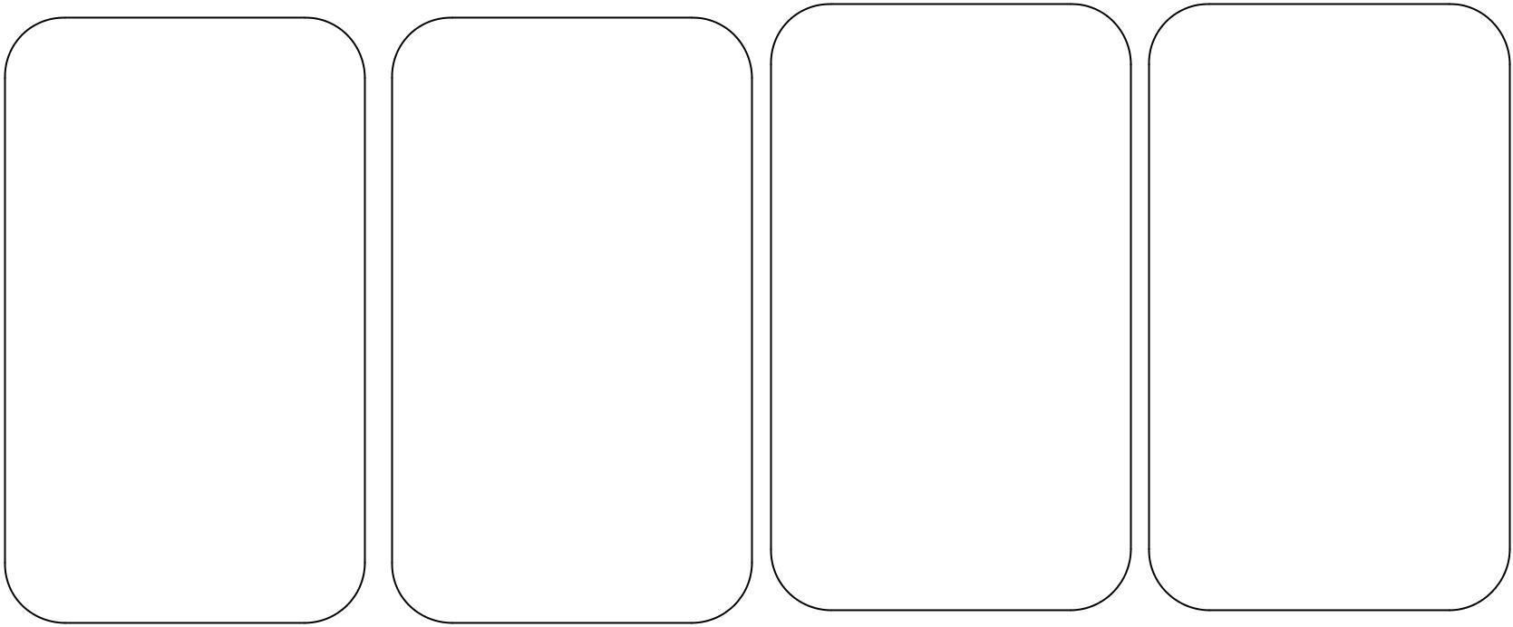

Physical | Cognitive | Psychological | Age- Appropriate
Physical | Cognitive | Development | Activities
Development | Development | Development | Activities

 |  |  |  | The psychosocial
The school age |  | At this age the child |  | The psychosocial
The school age |  | At this age the child |  | development in
children gain up to 3 |  | shifts from an |  | development in
children gain up to 3 |  | shifts from an |  | middle school
kg in one year. They |  | egocentric ways of |  | middle school
kg in one year. They |  | egocentric ways of |  | children will help
are much slower |  | thinking to a more |  | children will help
are much slower |  | thinking to a more |  | them understand
compared to the |  | mature, perceptive |  | them understand
compared to the |  | mature, perceptive |  | morality. By the Age
growth compared to |  | and imaginative way |  | morality. By the Age
growth compared to |  | and imaginative way |  | of 6 years they have
the previous years. |  | of thinking. There |  | of 6 years they have
the previous years. |  | of thinking. There |  | developed
They gain 8 |  | are genuine |  | developed
They gain 8 |  | are genuine |  | conscience. The later
centimeters in one |  | enthusiasms for |  | conscience. The later
centimeters in one |  | enthusiasms for |  | begin understand the
year and show |  | learning new |  | begin understand the
year and show |  | learning new |  | rules of the society.
preferences right or |  | concepts. |  | rules of the society.
left handed.
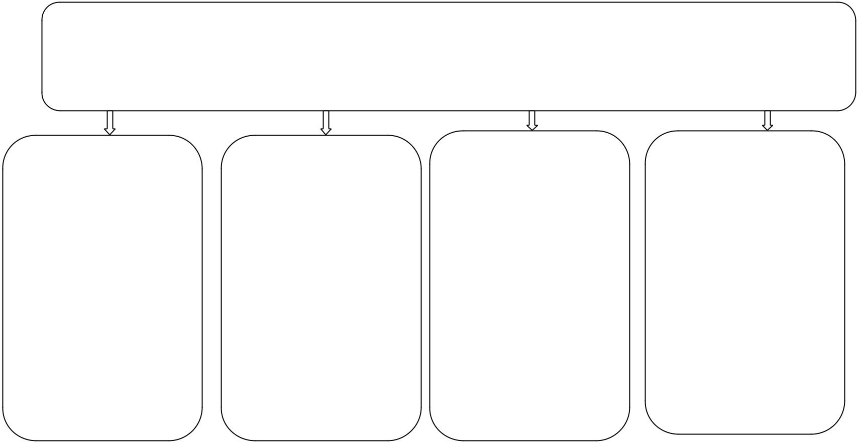

Health promotion

The age appropriate activity at this age include biking, walking and playing in the fields (Malina, 2012).

Health promotions among school aged children include learning disorders; Enuresis, scoliosis and kyphosis among others. These problems require the attention of health care professional.

 | Immunizations |  |  |  | Health Screening
 | There a number of |  |  |  | The health screening
 | vaccines that is |  |  |  | for school going
 | recommended for the |  |  |  | students involve
 | school going |  |  |  | cardiac screen,
 | children. They |  |  |  | cervical, testicular
 | include HPV, |  |  |  | and blood pressure (Hills, 2007).
 | Varicella,
 | chickenpox, tetanus
 | and pertussis (Hills, 2007).

Nutrition

The nutrition at this stage must be a balanced diet. The portion should be made up of half starch to provide energy due to the high activity of children in this stage. At this stage the children appetite is
high.

Injury Prevention

At this age due to high activity there various ways in which child can be injured. Hence various precautions should be kept in placed to protect the child at play time which includes wearing of the helmet.

ACTIVE LEARNING TEMPLATES THERAPEUTIC PROCEDURE A5

